Electromagnetism and Linear Graphs

TuHS Physics Research Project

1/2/2013
Braden Ackles, Ethan Joshi
This is the researched project proving ferromagnetism started in 2012 and finish in 2013 by Braden Ackles and Ethan Joshi

Table of Contents
Introduction 2
Background Information…………………………………………………………………………………………………………….2
The Problem……………………………………………………………………………………………………………………………….3
Hypothesis………………………………………………………………………………………………………………………………….3
Method 4
Results 5
Iron core…………………………………………………………………………………………………………………………………..5
Steel core…………………………………………………………………………………………………………………………………..6
Conclusion 7
Work cited/ Bibliography 8

Introduction

  - Background information
Electromagnets have been used for a long time and the basic physics behind them makes sense. There are some uncommon terms through when it comes to electromagnetism and just magnets in general.
For the first a basic concept that is the basis of why magnetism exists, ferromagnetism. Ferromagnetism explains the basic mechanism by which materials such as iron form permanent magnets. Also among all the types of magnetism ferromagnetism is the strongest. It is also the only type of magnetism that is strong enough to be felt by a person or animal. Other types of magnetism can only be measured with magnetic field sensors. (Source 1 &2 & 3)
Ferrimagnetism is included in ferromagnetism because the two have many things in common. Ferrimagnetism is included with ferromagnetism in the only magnetic fields strong enough to be felt. Ferromagnetic material is a material in which magnetic moments of the atoms on different subattics are opposed, as in anti-ferromagnetism however, in ferrimagnetism materials, the opposing moments are unequal and a spontaneous magnetization remains. (Source 2 & 3)
Ferrous materials are all materials that are a compound of Iron (Fe2+). Examples include: Iron, Steel, and some forms of stainless steel.

  - The Problem
Trying to push the boundaries of science we decided to see if an electromagnet would form a linear graph of current to magnetic strength. This is all done to reason because at some point depending on the magnet, increasing the current will stop increasing the magnetic strength. (Source 1 & 2 & 3 & 7)
  - Hypothesis
If the current is increased in an electromagnet then the magnets strength will increase linearly to the increase in current because of ferromagnetism.
Our variables will be
- Cores
  - Iron (Fe2+) Control
  - Steel(Fe3C) independent
- Magnet wire:
  - 22 gauge magnet wire with protective coating (Constant)
- Distance from Magnetic field sensor (from here on referred to as MEMS)
  - 4 mm (Constant)
- Current
  - Start at .00 Amperes and increase by .05 till maximum magnetic strength is achieved or wire begins to melt.

Method

  - Setup
The setup is fairly simple. We will start by setting up the power supply (A) and the current reader (B). We will then set the MEMS stationed upside down so that the experiment does not get tall. Then we will set the front of the magnet (D) facing the MEMS (C) so that the magnetic field is facing the MEMS and not opposing it. Since the MEMS is vector based it would work either way the magnet is facing but having the magnetic field opposing the MEMS would cause a weird graph. The distance between the magnet and the MEMS is 4mm and is constant. When setting up the MEMS we will set the amplification to low so that we can get more accurate data. The materials used in the experiment were the voltage regulator, the current reader, the MEMS, and the electromagnets. (See image 1 & 2)
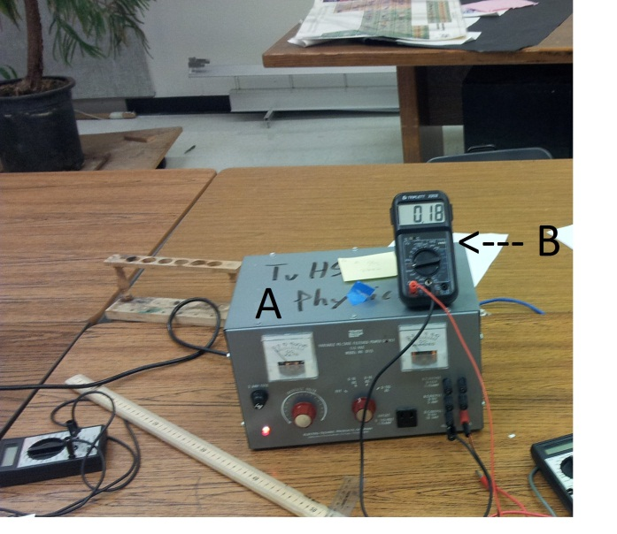(Image 1)
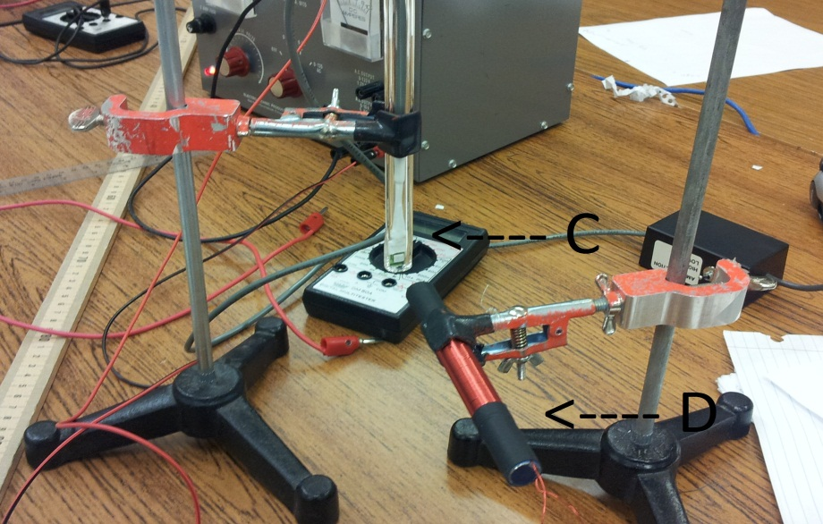(Image 2)

Results
  - Iron Core
Our results actually surprised us, based on how many errors could have occurred there were very few errors that actually did. The Iron core had more data points because it was a larger magnet and was able to handle larger amounts of current. However it was still almost a linear line. Other than two large jumps at .96 Amperes and 1.31 amperes it had a very strong correlation of .9979. That is an extremely strong correlation. The errors could have been caused by human error which is probably the most likely such as me bumping the table, but other possible errors could be fluctuations in the magnetic field in that point of time or errors that the MEMS had when measuring the magnetic field. (See image 3, left & 4, right).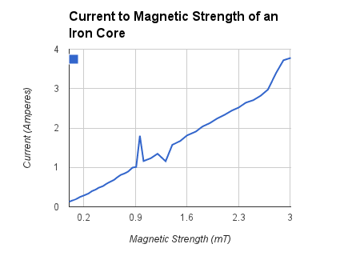 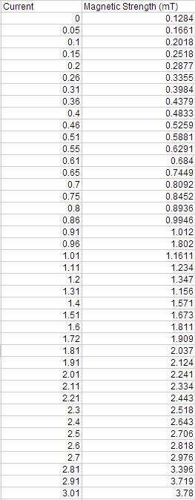

  - Steel core
They steel core produced an even stronger line of correlation. The correlation was .998588. The Steel core did not have an error as large as the iron core did but this is probably because there was less human error when taking the data because I had mastered the rhythm of how to collect the data. The steel core was even more surprising then the iron core because I did not expect the iron core to have such a strong linear regression so I expected the steel core to have an even weaker linear regression. But it was quite the contrary since the steel core had an even stronger correlation.
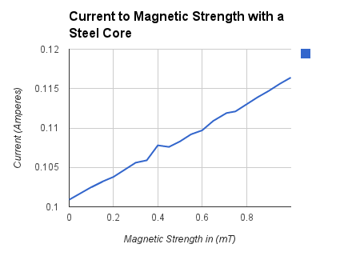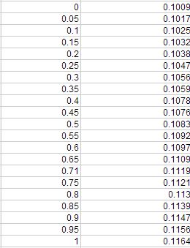

Conclusion

The results showed that both the iron and steel cores form linear lines of current to magnetic strength. Our hypothesis was correct even to our own surprise. Both iron and steel cores showed strong lines of linear regression. It was unexpected that the steel core showed a stronger line of regression. I think that the data came out this way because there were double the data points for the iron core than the steel core. Giving the iron core more chances to stray from a perfect linear line. The main errors were caused when taking data for the iron core and were most likely that I bumped the able and the magnet got misaligned with MEMS. If I was to do the experiment over again I would use larger magnets with a larger wire to enable me to use a larger current. I would also track the voltage to help solidify what the current should be and make sure it stays steady because there were times where I spent 2 minutes trying to get it to get even close to a certain current. Over all the experiment was fun and I learned a lot about magnetism.

Work cited/ Bibliography

Source 1: "Electromagnet." Wikipedia. Wikimedia Foundation, 11 Jan. 2012. Web. 06 Nov. 2012. <http://en.wikipedia.org/wiki/Electromagnet>.
Source 2: "Ferrous." Wikipedia. Wikimedia Foundation, 30 Oct. 2012. Web. 06 Nov. 2012. <http://en.wikipedia.org/wiki/Ferrous>.
Source 3: "Ferromagnetism." Wikipedia. Wikimedia Foundation, 11 May 2012. Web. 06 Nov. 2012. <http://en.wikipedia.org/wiki/Ferromagnetism>.
Source 4: "Ferrimagnetism." Wikipedia. Wikimedia Foundation, 22 Oct. 2012. Web. 06 Nov. 2012. <http://en.wikipedia.org/wiki/Ferrimagnetism>.
Source 5: "How Electromagnets Work." HowStuffWorks. N.p., n.d. Web. 06 Nov. 2012. <http://www.howstuffworks.com/electromagnet.htm>.
Source 6: Gargulinski, Ryn. "How Electromagnets Work." EHow. Demand Media, 15 Apr. 2009. Web. 06 Nov. 2012. <http://www.ehow.com/how-does_4570421_electromagnets-work.html>.
Source 7: "MEMS Magnetic Field Sensor." Wikipedia. Wikimedia Foundation, 01 May 2013. Web. 17 Jan. 2013. <”http://en.wikipedia.org/wiki/MEMS_magnetic_field_sensor”>.

